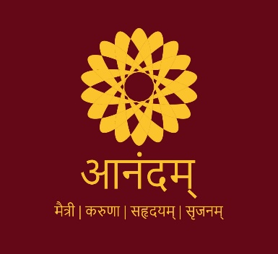

Anandam- an initiative to instill the joy of giving among the young generation has been included as a Graded subject for all First-Year students of UG and PG Courses studying in Jai Narain Vyas University (JNVU) except law students, from academic session 2020-21. Honorable Vice Chancellor Prof. P.C. Trivedi constituted a committee for smooth implementation of course under leadership of Prof. VimlaShereon as Committee Coordinator and Prof. Praveen Gehlot, Prof. O. P. Tak, Dr. Hemlata Joshi, Dr. Hitendra Goyal, Dr. Rishabh Gehlot and Dr. Neelam Kalla as members. The committee followed the program design as per the guidelines of Government of Rajasthan.

Course Objectives:
- Anandam is a subject that aims to instill the joy of giving and sharing among young people through communityparticipation, helping them to be responsible citizens and initiators for a change in society.
- The faculty will inspire students for Individual Social Responsibility and will inculcate the qualities of compassion, an open mind, a willingness to do whatever is needed and positive attitude among students.
- Imagination and creativity are to be appreciated.
- An Aim and Vision to be developed in students.

In order to pursue this course, students are expected to engage in:
- An individual act of Goodness-Caring, Sharing and Giving (Time and Energy) every day.
- Group Activity: A project in service of the local community (Group Community Service Project) in collaboration with NGOs.
- The faculty (All Anandam Team Members) emphasize shift in focus - Happiness is not acquiring things but permanent happiness comes from giving, sharing and caring for someone.

Expected Course outcomes:
- Community Service Programs are very effective for students’ personal and social, ethical, and academic development. These effects depend on the characteristics of the program chosen.
- Involvement of students in community work has as impact on development of student’s skills such as creativity, critical thinking, innovation, passion and positivity.
- They would examine social challenges and problems, assess the needs of community evaluate previous implemented projects and think of further solutions.
- They would learn to cooperate and collaborate with other agencies and inculcate leadership qualities.

Activities undertaken for Anandam:

Designing of Implementation Mechanism
Core committee held several meetings and came up with an effective implementation mechanism of Anandam course in the university. Considering the challenges of covid pandemic such as social distancing, uncertain lockdowns, delayed admissions and examinations, the focus for current academic session was to initiate the program effectively and a preparation of a roadmap for future years that has been successfully designed and implemented.

Updating all Information through videos and links on University Website
All the guidelines and proforma for daily Anandam activities and group projects were approved by academic council and updated on university website. Core committee members Dr. Hitendra Goyal and Dr. Neelam Kalla also developed comprehensive videos for faculty members and students for enhanced understanding. Both the videos can be accessed on university website.

Orientation Programs
For developing an understanding of Anandam amongst faculty members and students, a series of orientation programs were conducted by team Anandam.
The first orientation program targeted all the deans of faculties, heads of departments, directors of institutes and Anandam mentors. Afterwards a series of orientation programs was undertaken at different faculty, department or institute level for students.

Memorandum of understanding with Heartfulness Education Trust
Another milestone was signing an MoU between Jai Narain Vyas University, Jodhpur and Heartfulness Education Trust. The above collaboration led to a series of webinars and programs for students for understanding life concepts and skills.

Social Welfare Activities by Students
Students of JNVU various departments under guidance of Anandam core committee and mentors appointed, have undertaken group projects and initiated to maintain Anandam diaries, based on which, they will be graded.

Webinars Under Anandam during Lockdown
During the second wave of Covid pandemic, webinars were organized wherein eminent speakers, spiritual leaders interacted with students and faculty members.

Proposed Future Activities
Anandam Day will be celebrated to mark the achievements and contribution of student during Anandam course.

Constitution of Anandam Core Committee

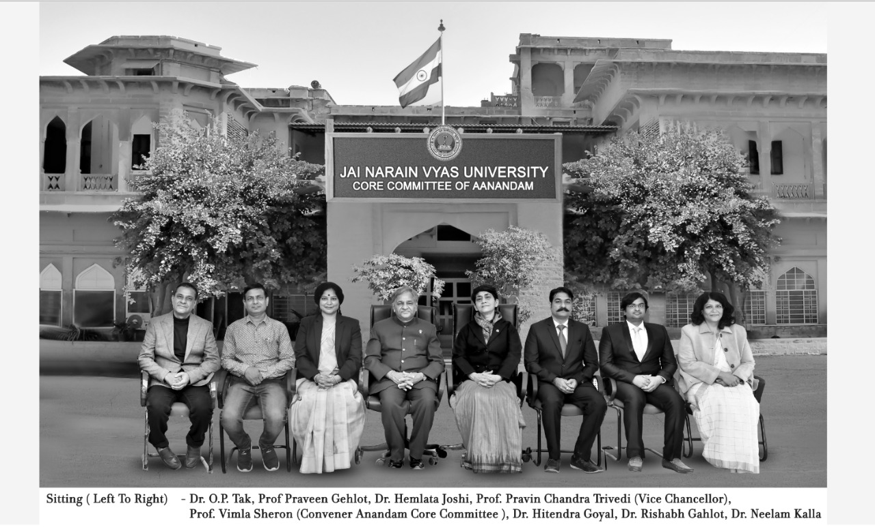
Activities under Anandam: Glimpses

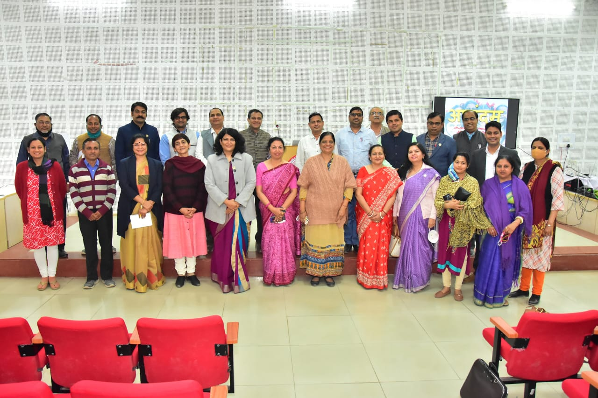
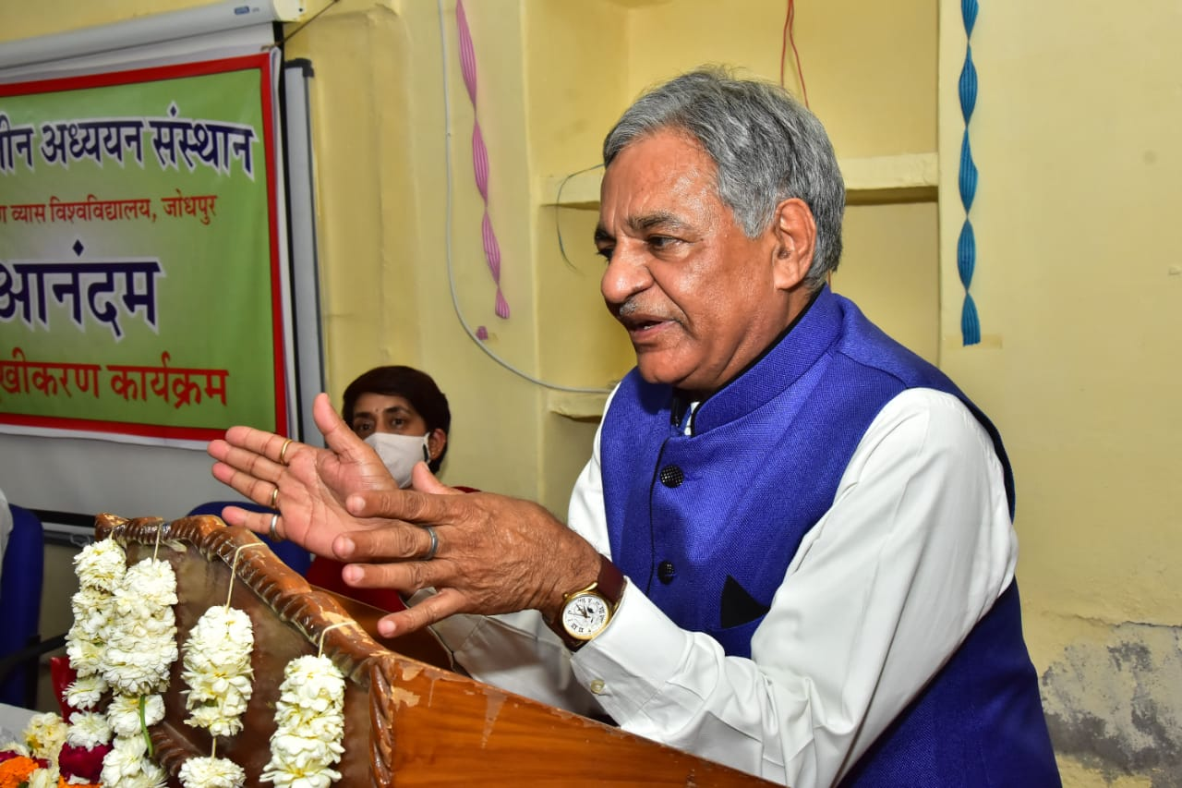
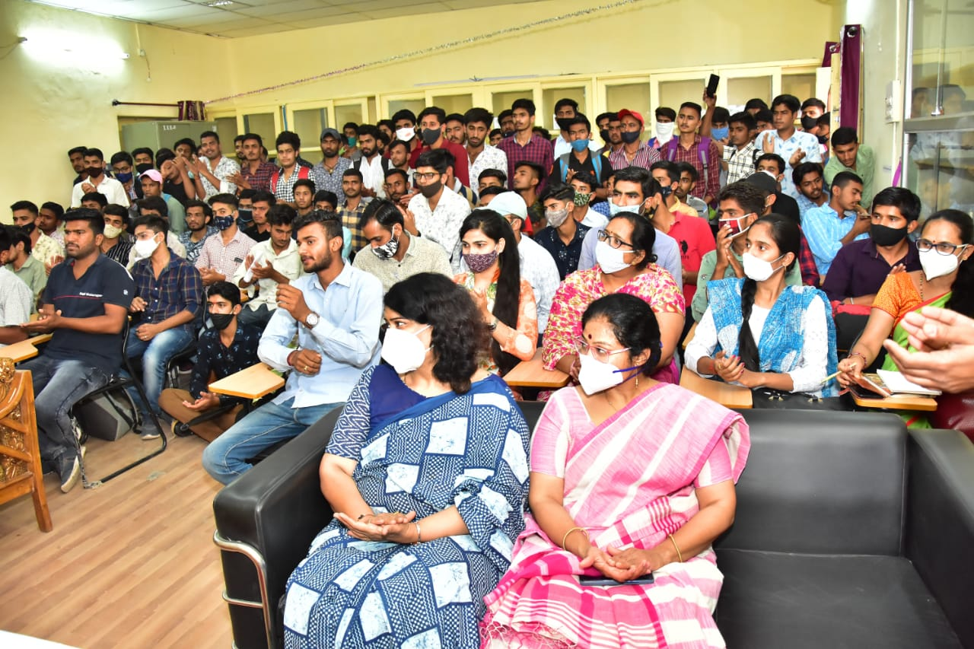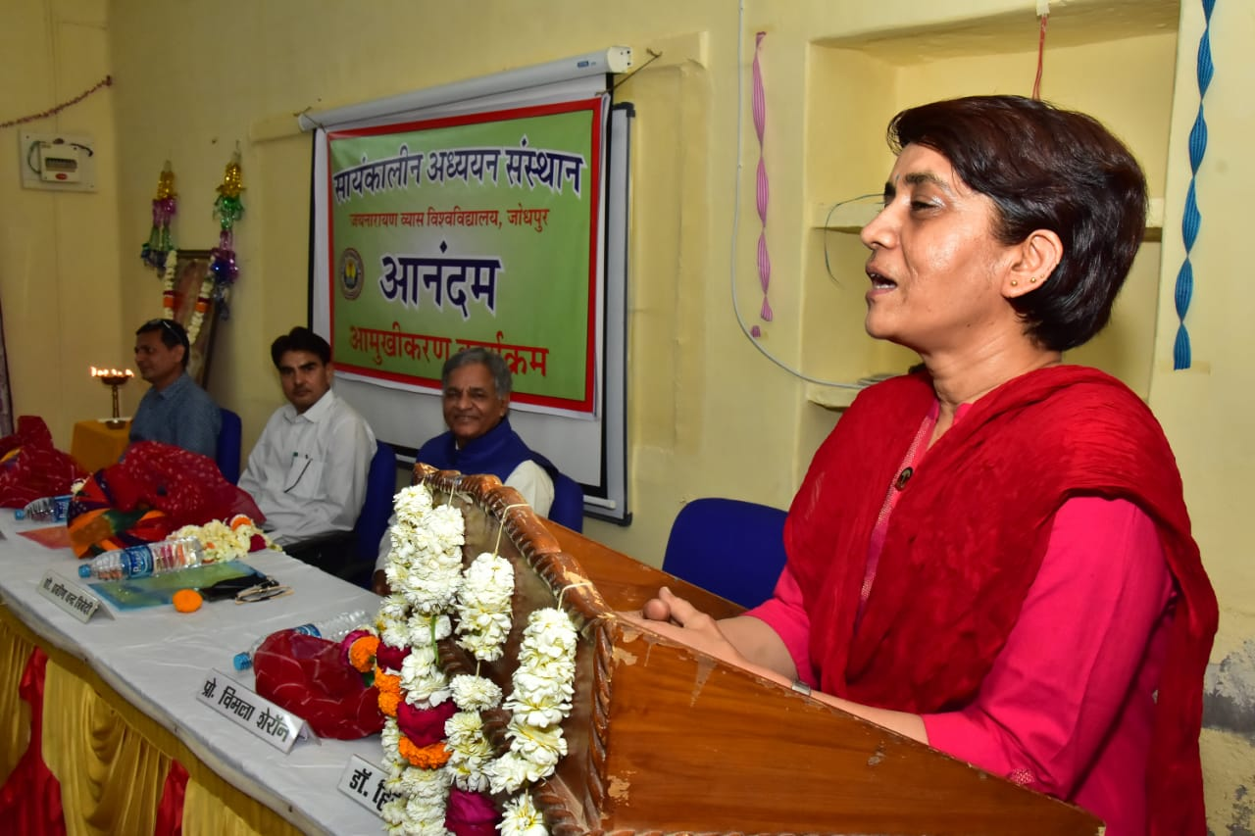
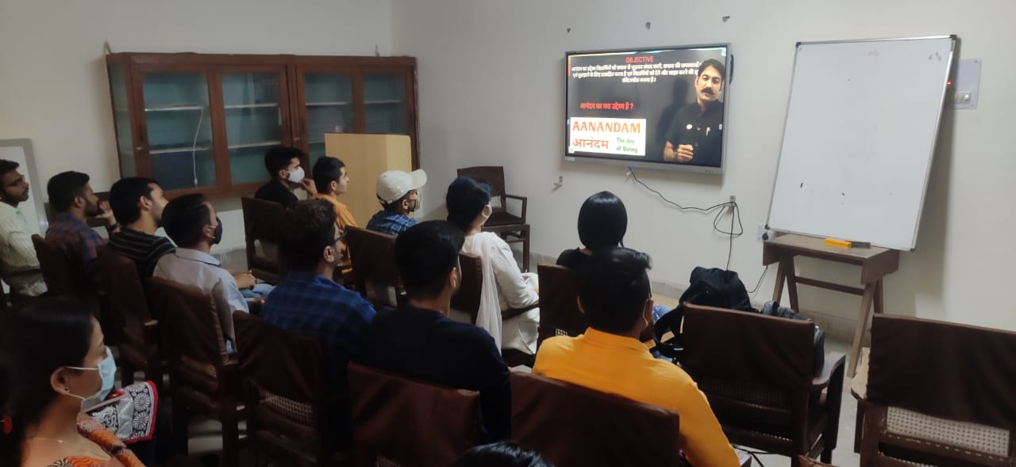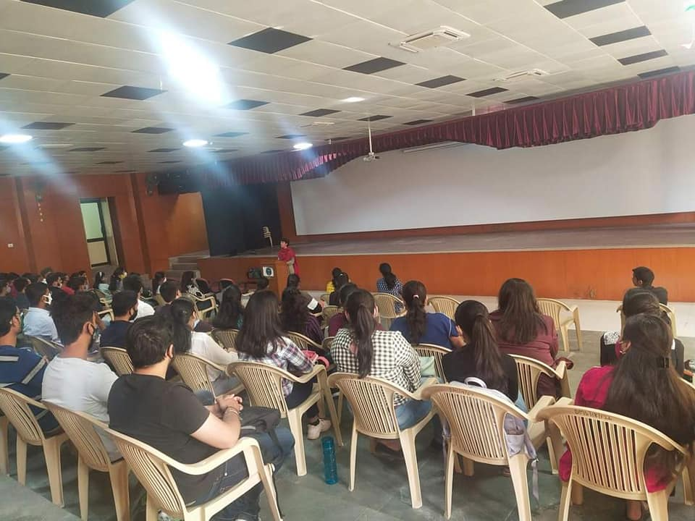
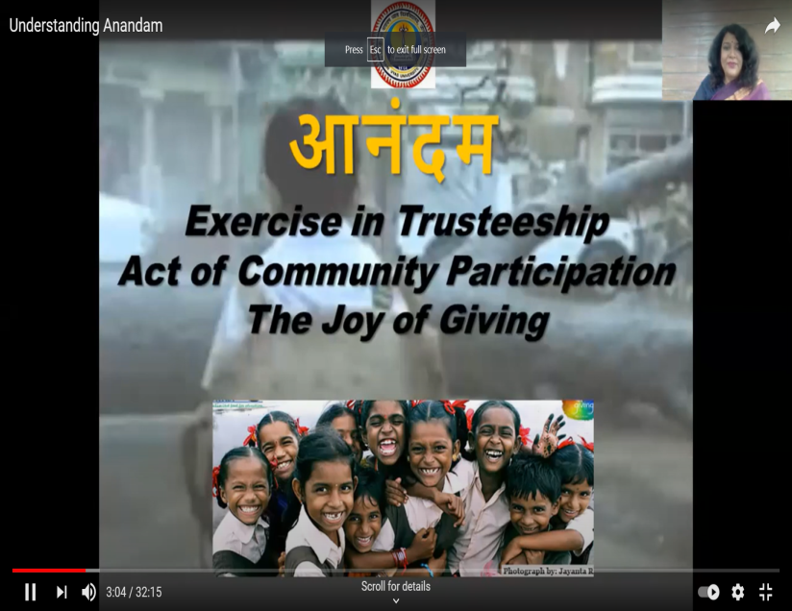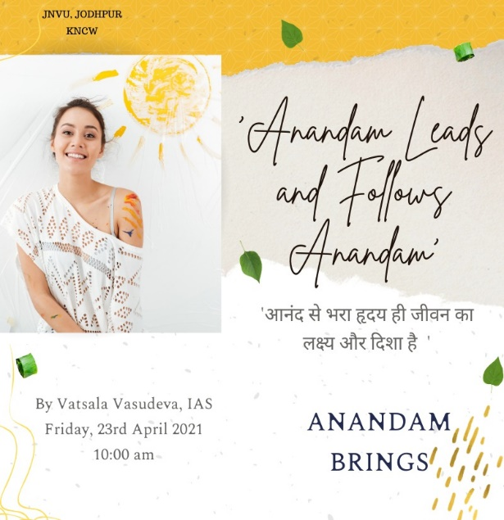
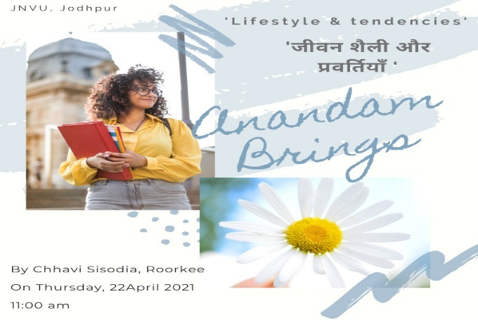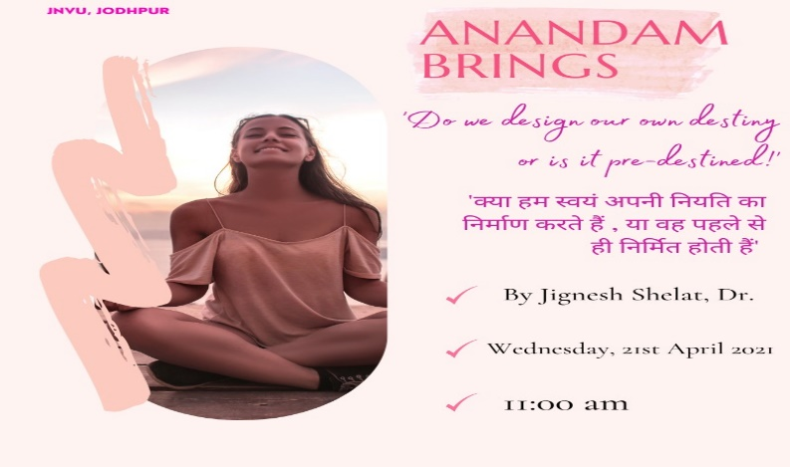

MOU of Jai Narain Vyas University with Heartfulness Trust for Anandam

