# M.B.M. Engineering College

# Department of Production & Industrial Engineering

Webinar on

*5S: A Japanese Methodology for Workplace Management*

In association with

# Internal Quality Assurance Cell (IQAC)

**November 2, 2020**

**Session – Report**

**Patron**

**Prof. P. C. Trivedi**

Hon'ble Vice Chancellor

Jai Narain Vyas University Jodhpur

Resource Person : **Prof. Milind Kumar Sharma**

Director (IQAC) & Head

Department of Production & Industrial Engineering

M.B.M. Engineering College

Faculty of Engineering & Architecture

Jai Narain Vyas University, Jodhpur

**Date:** November 2, 2020 Monday

**Time:** 11:00 AM to 12:00 Noon

**Webinar Organizing Committee**

**Dr. Lakhan Patidar, Mr. Amit Vishwakarma, Mr. Prashant Athanker, Mr. Mohd Vaseem**

Assistant Professor (TEQIP-III), P&IE

**PREAMBLE**

The Department of Production & Industrial Engineering in association with Internal Quality Assurance Cell (IQAC), M.B.M. Engineering College, Faculty of Engineering & Architecture, Jai Narain Vyas University, Jodhpur conducted the webinar on

*“5S: A Japanese Methodology for Workplace Management”* for the students, scholars, teaching faculties, practitioners, consultants, entrepreneurs and people from industry and service sector.

MBM Engineering College is one of the oldest Engineering colleges in India established on 15th August 1951 by the government of Rajasthan, the college boasts of its high academic & technical standards having 12 departments including the recently added Petroleum Engineering stream. Later, this college was merged with the University of jodhpur in year 1962 presently known as the Faculty of Engineering & Architecture, of Jai Narain Vyas University, Jodhpur. This University has 39 departments and 6 centres.

Production & Industrial Engineering Department was established in year 1990 to impart quality education in the area of Production and Industrial Engineering. The department has well equipped CAD/CAM lab, Robotics, Industrial Engineering, Advanced testing lab, Product Design and Development Laboratories. The department has specialization in Manufacturing and Industrial Engineering, Automation (CAD/CAM&CAPP), Supply Chain Management, Performance Measurement, Information Systems.

**Internal Quality Assurance Cell (IQAC) – Vision**

To promote quality culture as the prime concern of Higher Education Institutions through institutionalizing and internalizing all the quality-enhancing and sustaining initiatives taken with internal and external support.

**Objective**

The primary aim of the IQAC is

* To develop a mechanism to promote conscious, consistent and catalytic action plans to improve the academic and administrative performance of the institution.
* To promote institutional quality enhancement and sustenance through the internalization of quality culture and institutionalization of the best practices.

IQAC offers various intra- and inter-institutional workshops and seminars/webinar on quality- related themes and promotion of quality circles.

Prof. Milind Kumar Sharma was Convener and Dr. Lakhan Patidar was Co-Convener of the programme. Total number of participants showed their interest for webinar on “*5S: A Japanese Methodology for Workplace Management”* were 841. Out of them many people have belonging to very reputed institutes and university. Participants have registered in India from all region as well as some of the participants having registered from others country as shown in below pie chart.

**Detail of Foreign Participants**

**Details of registered participants**

Of these, around 190 participants took part in online webinars which included teachers (37%), students: UG, PG and PhD scholars (47%), practitioners, consultants, entrepreneurs and people from the industry and services sector (16%).

Prof. Milind Kumar Sharma, Head, Department of Production & Industrial Engineering, and Director (IQAC), M.B.M. Engineering College, Faculty of Engineering & Architecture, Jai Narain Vyas University, Jodhpur delivered the lecture.

# The course content delivered in the webinar is as follows:

The impact of *5S* in day-to-day activity with best suitable real life examples was discussed in this session.

The Co-Convener of the webinar Dr. Lakhan Patidar briefed about the IQAC and session. The resource person of this webinar was Professor Milind Kumar Sharma, Head, Departmental Production and Industrial Engineering, and Director Internal Quality Assurance Cell (IQAC), Faculty of Engineering & Architecture, MBM Engineering College, Jai Narayan Vyas University Jodhpur. The resource person explained the usefulness of *"5S: A Japanese Methodology for Workplace Management"* and stated that *5S* can be a game changer for strategy organizations. Neither capital nor sophisticated training sessions are required for *5S*. It suggests methods for streamlining the management and use of the workplace, by identifying and storing the objects used, based on the frequency of their use, the work area and the objects to be maintained and thus the new order to improve overall efficiency and effectiveness. He discussed the basic concepts used in the day to day operation with best suitable real life examples which are essential for the understanding of *5S*. He emphasized that 5S implementation takes place through dialogue and arriving at a consensus about standardization, which develops an understanding between employees to develop a work culture for how they should work in order to eliminate rework, waste and inefficiencies. It also paves the way for successful civic implementation. He inspired the audience by lively interacting on topics to take proactive initiatives and propose reforms on how things should be done, rather than feeling powerless in their respective roles.

Also the feedback about the session was collected from all the participants to improve the sessions that will be conducted in the mere future. The sample details collected from the participants is as follows:



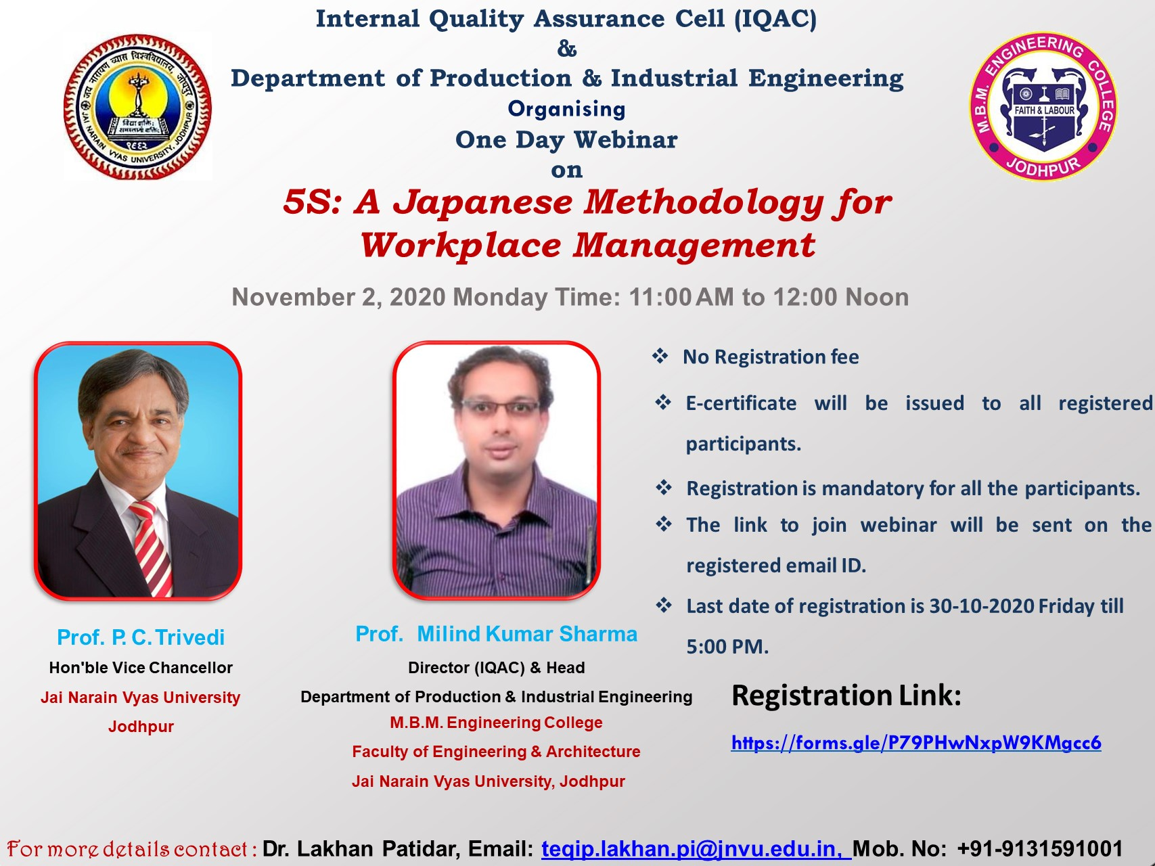

**5S: A Japanese Methodology for Workplace Management Webinar Brochure**

This programme is arranged in the motive of sharing the knowledge and practical experience of Professor Milind Kumar Sharma, who has a long years of experience in research. The overall organization and deliverance of the webinar was helpful and satisfied the participants.

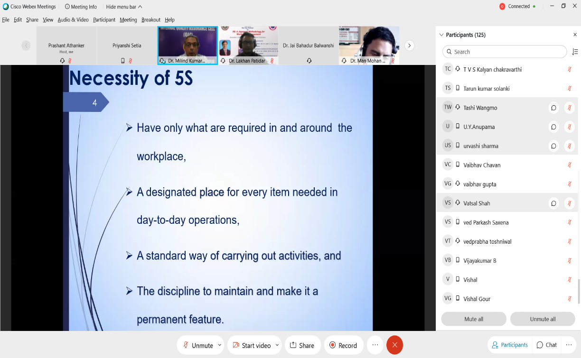

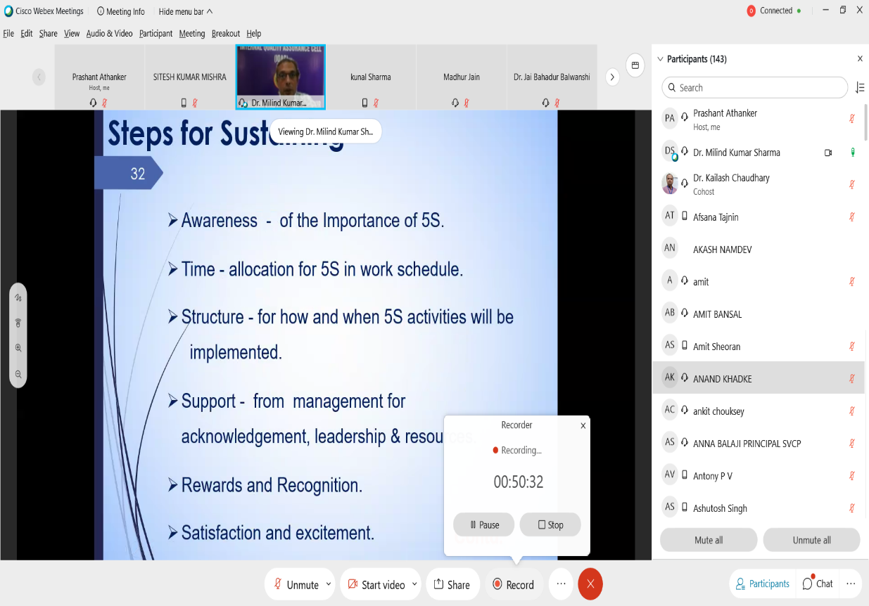

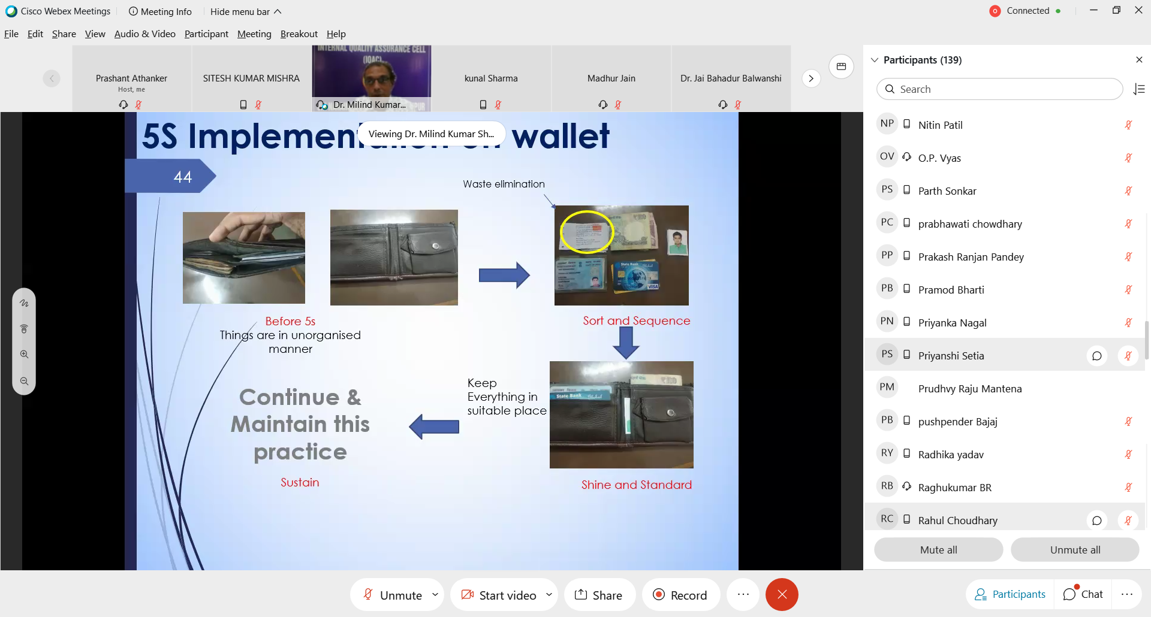

**(Professor Milind Kumar Sharma interacting with session participants)**

# Feedback Form

# C:\Users\My Pc\Desktop\PI WEBINAR SERIES\@2. FIVE S\3. Post webinar\feedback snap1.png C:\Users\My Pc\Desktop\PI WEBINAR SERIES\@2. FIVE S\3. Post webinar\feedback snap2.png

*Feedback form:* <https://docs.google.com/forms/d/1sUCpXF7tbCTlwHh3KGOZY3xDFjbWy02pDTy1Vbr7UP4/edit>

**Sample Feedback Responses obtained through Google form from the participants.**



The objective of the webinar was achieved. The overall session discussion benefitted the faculty members, students: UG, PG & PhD scholars, practitioners, consultants, entrepreneurs and people from industry and service sector. This webinar would help the participants help in improving day-to-day operations, elimination of waste & non value adding activities, enhanced work quality and productivity. The webinar concluded with the distribution of e-certificates to the participants.

------------------------------------------------------ END OF REPORT ----------------------------------------------------